Creating Invoices (bills, statements)
- Open the Business Invoice from the Database Zones folder (Shared drive>>chsbused >> Yearbook >> Database Zones.
- Key in today’s date
- Click on the text that reads [Name] and type the name of the contact person, company name, street address, city, state, zip and phone number
- In the description, key the type of ad they purchased
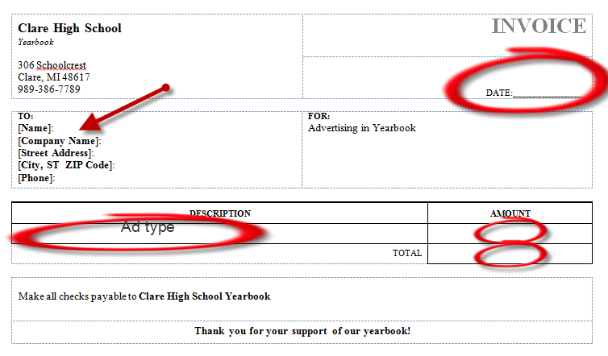
- In the Amount, key the amount and then total the amount

- Complete the bottom portion of the Invoice the same way
- Cut the paper in half and MAIL THE TOP HALF
- File the BOTTOM HALF

Addressing an Envelope
- Copy the Address of the Business from the invoice, except the phone number.
- Click on the Mailings tab on the Menu bar and click Envelopes
- Because you already copied the address, it will be in the Delivery Address portion
- Type in Clare High School Yearbook, 306 Schoolcrest, Clare, MI 48617 in the Return Address portion.
- Tell everyone in the class not to print, add an envelope in the printer (see picture on printer) and then print.
- Insert invoice in envelope and give to Mrs. Cleary to mail.
- Make sure you record that you sent an invoice on your database.

