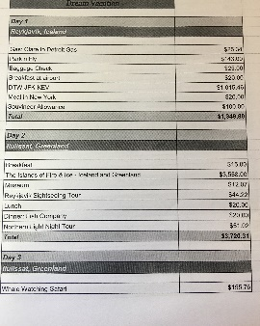
Rubric for Itinerary & Budget
Using an Excel spreadsheet or Google Sheets
Include things to do everyday | 10 7 5 3 0
Have a total of money spent each day | 10 7 5 3 0
Include at least 2 meals and location of each restaurant | 10 7 5 3 0
Include proper spelling & punctuation | 10 7 5 3 0
Spreadsheet is attractive including colors and borders | 10 7 5 3 0
Includes the total amount spent for the entire week | 10 7 5 3 0
Total | /50

