How Do Sales Taxes Compare Among States?

Data Crunch
Taxes #5

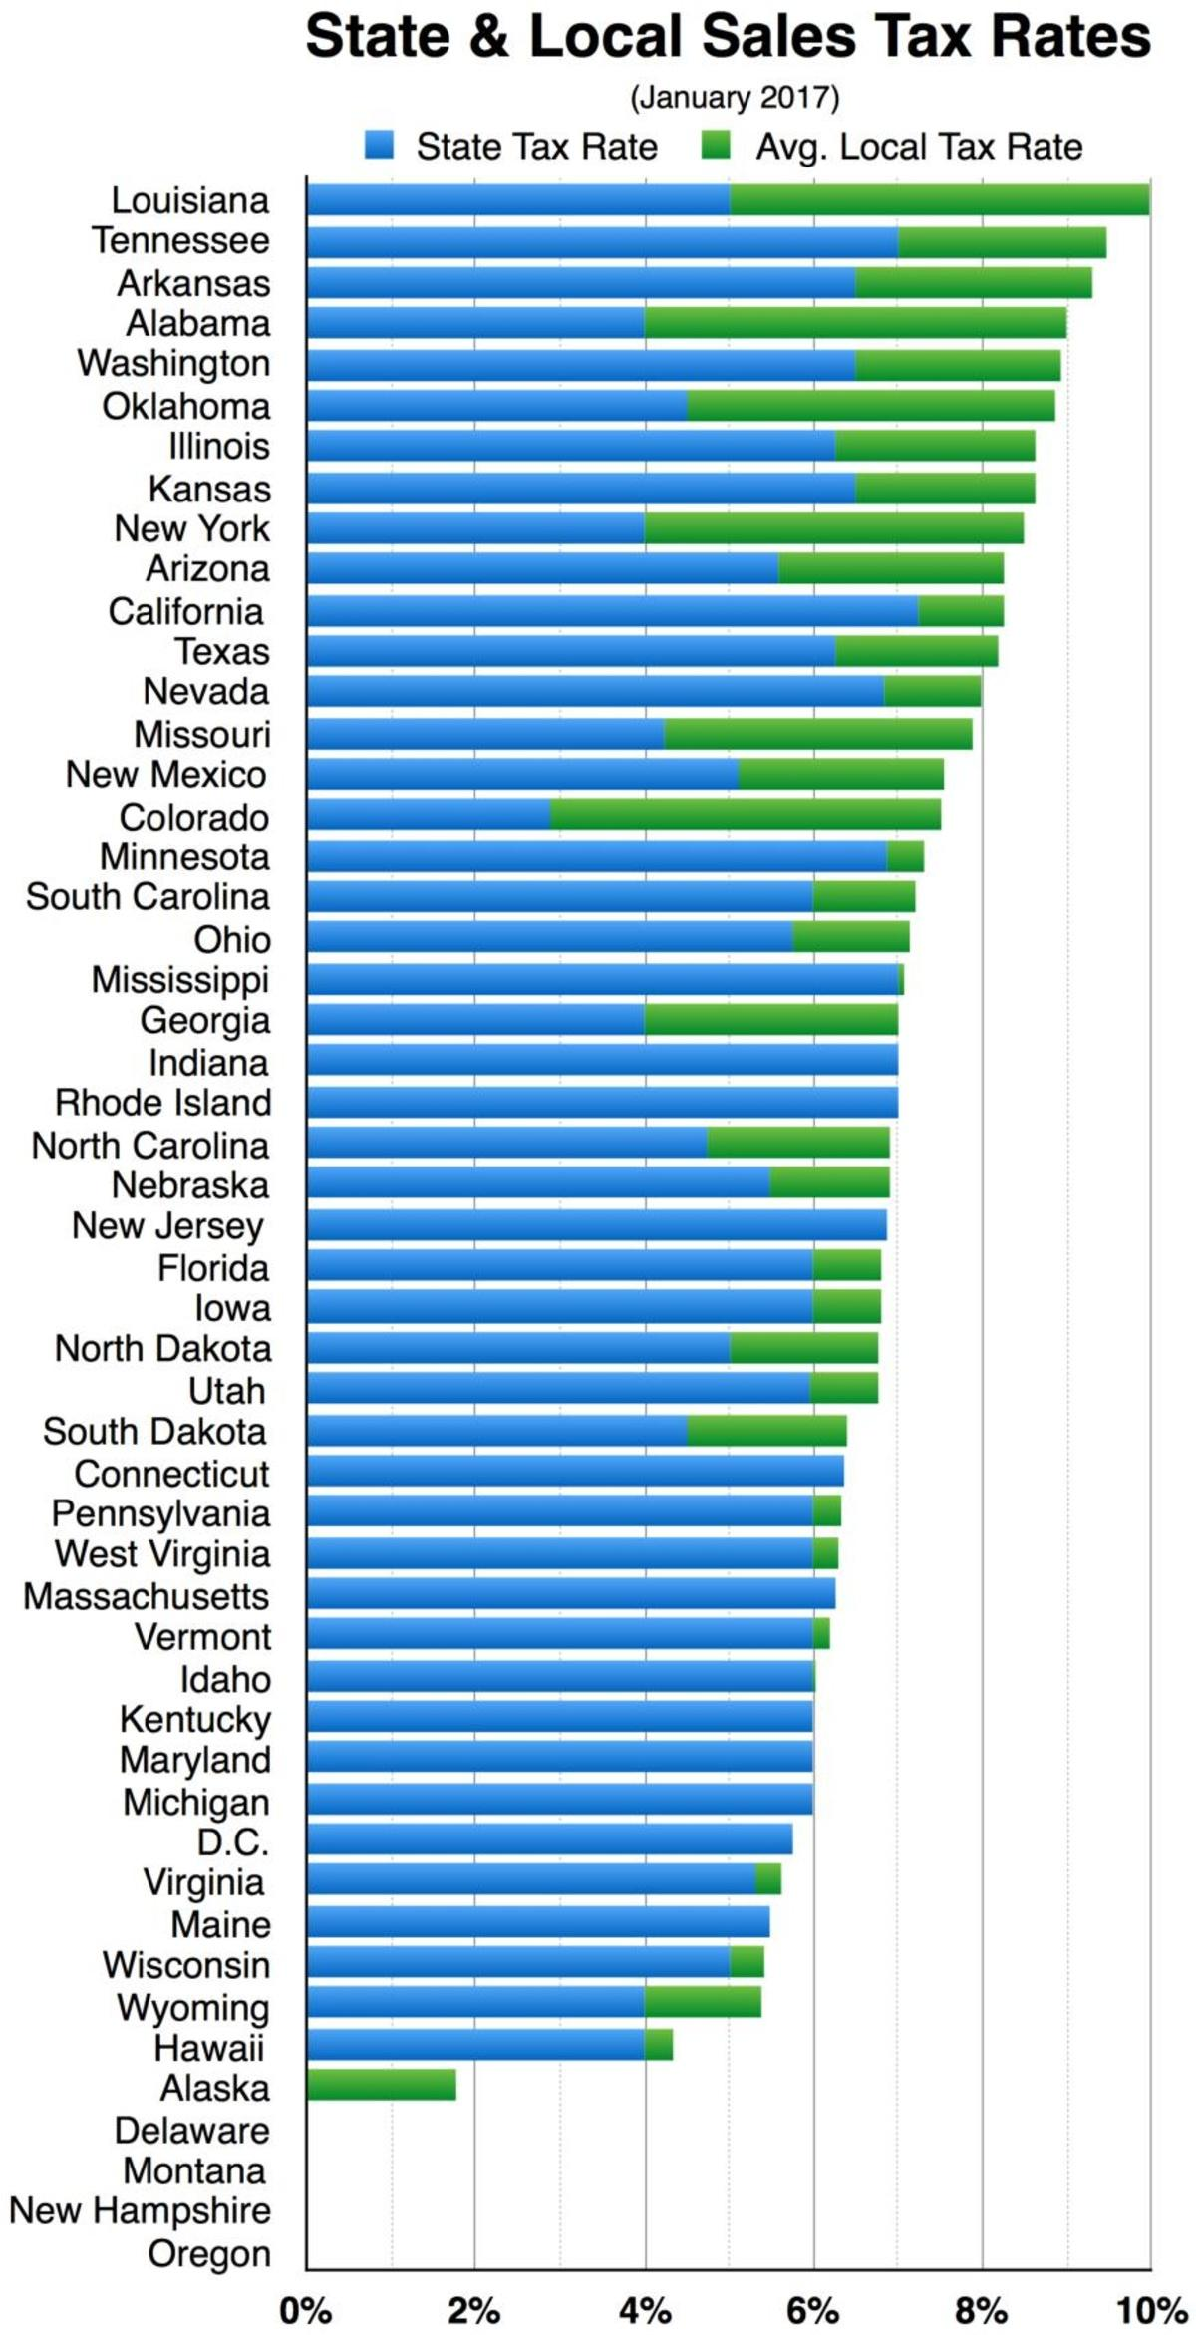 | - What is the average sales tax rate paid by citizens of your state?  DOK 1
- In which states is there no statewide sales tax?

DOK 1
- Compare the total average cost of a $100 purchase in Louisiana with the same purchase made in Georgia.

DOK 2
- What can you infer about tax law in a state such as Indiana, Connecticut, or Michigan?

DOK 2

- This graph was created based on data in January 2017. If state and local tax data were collected and presented again in January 2018 and January 2019, would you expect substantial change among the graphs? Explain your thinking.

DOK 3

